Delivering secure Copilot solutions in public-sector organisations

July 2025

Contents
Title 1
Contents 2
Background 2
More about Secure by Design 2

Background:
This document aims to help public-sector organisations choose secure designs for their Microsoft Copilot solutions, as part of the Secure By Design journey. It touches on:
- An architectural overview of how Copilot works
- Principles for AI deployments, and principles for Secure By Design
- Specific technical concerns to be addressed in the design
- Organisational considerations around process, policy, and stakeholders

More about Secure by Design

- Guide to adopting Secure by Design
- Secure by Design policy
- Implementing Secure by Design

Copilot solution architecture
Architecturally, Microsoft treats Copilot as a middle layer, which sits between Microsoft 365 apps and MS Graph, within your m365 tenant:
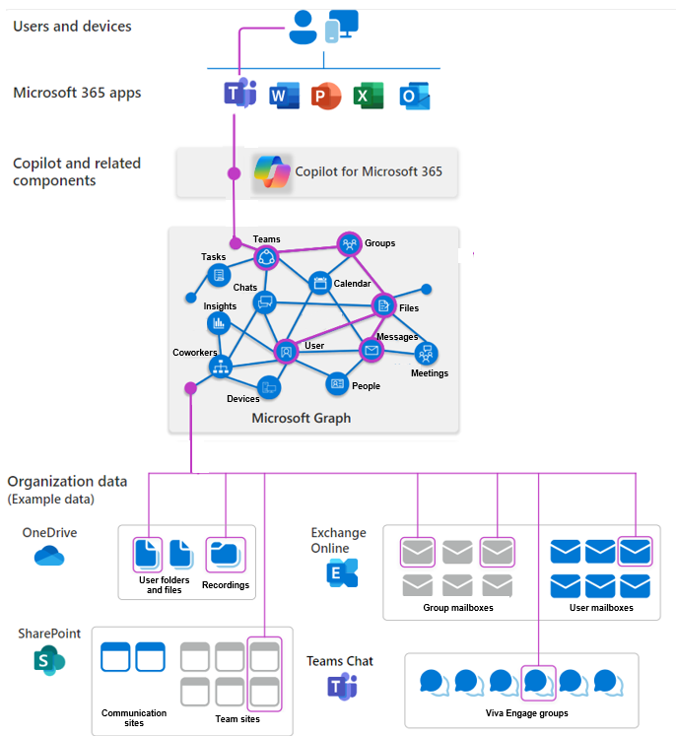
Users can generate Copilot prompts from an m365 application; Copilot then reaches through MS Graph to use the underlying business data. Hence there are limitations with locally-saved files; Copilot would typically access files through OneDrive.

Principles for securing Copilot solutions
The AI Playbook sets out principles for the development and deployment of new AI services.
- Principle 1: You know what AI is and what its limitations are
- Principle 2: You use AI lawfully, ethically and responsibly
- Principle 3: You know how to use AI securely
- Principle 4: You have meaningful human control at the right stages
- Principle 5: You understand how to manage the full AI life cycle
- Principle 6: You use the right tool for the job
- Principle 7: You are open and collaborative
- Principle 8: You work with commercial colleagues from the start
- Principle 9: You have the skills and expertise needed to implement and use AI solutions
- Principle 10: You use these principles alongside your organisation’s policies and have the right assurance in place
These are not the same as the Secure By Design principles, but they align well.
The Secure By design team have developed a mapping between the two sets of principles: https://github.com/co-cddo/SbD-development/blob/main/Artificial%20Intelligence/Secure%20by%20Design%20Principles%20for%20AI%20Implementation%20and%20Deployment.docx

LLM Scope violation
Recent headlines have focussed on the “Echoleak” vulnerability which was recently patched by Microsoft. However, this is one example of a broader family of vulnerabilities which AIM call “LLM Scope violation”, which is broadly similar to a prompt injection vulnerability, but AI specific; a threat actor could inject instructions which cause the AI to go in an unexpected new direction. The echoleak vulnerability is specifically about data leakage, but other future instances are likely to involve other impacts such as denial-of-service, or manipulating business data.
If your organisation uses templates for assessing threats and vulnerabilities, it is important to ensure that these templates are updated to reflect the new family of vulnerabilities.

Copilot deployments can face problems with overshared links.
Copilot can very efficiently scrape internal data; if there is a pre-existing problem with overly permissive links within your organisation, Copilot can amplify this, accessing large volumes of data which a human user would have been less likely to find (even though they technically had access).
Tools such as Purview can help, but if you find this problem with Copilot it may indicate a broader opportunity for improving ACLs &c. This approach is likely to work best in collaboration with your data protection / data governance team.

Minimising the attack surface

Minimising the attack surface is a key architectural principle of Secure By Design.
If your organisation uses Microsoft Defender, its attack surface reduction tools will be useful, as they are effectively integrated with how Copilot accesses your organisation’s data.
At a lower level of the stack, many government organisations using Copilot are likely to have Intune too. Although the primary focus of access controls is at the user & service level, Intune allows some further controls for Copilot usage at a device level.
Take great care when considering any requirement to let data outside the compliance boundary, ie a Bing query.

Permissions
Plan your permission model carefully. The controls around Copilot’s access to underlying data are based on the existing permissions of individual user, rather than the organisation level, so different users in your organisation using Copilot in the same way could have different outcomes, depending on which data they can read - this will need attention in the detailed design and in functional testing of your service

Control choices and testing
Copilot controls are largely based on your organisation’s existing m365 controls. Therefore, most government organisations are likely to have a relatively solid control set in place already, but now is a good time to review it, and also to consider potential gaps or tensions which might affect the security case for your Copilot service.
Microsoft documentation shows that your data should stay within the boundary of your own service, and the existing policies of your m365 tenant are applied; but bearing in mind the increased concerns around AI, and the new service making new use of existing controls, your solution is likely to need further control testing, to get sufficient assurance for go-live. This should pay extra attention to any new connectivity added by the project.

urlToltemResolver
There may be significant technical-security benefits to adding urlToltemResolver, which helps detect when users share external-facing URLs

Organisational concerns for Copilot solution design

Training, awareness, and visibility
Microsoft offers courses on Copilot, Civil Service Learning offers an AI course, and there are a number of other training options from other suppliers. This helps address a skills shortage which has been identified as a constraint on public-sector digital delivery more generally. Training will help you meet the AI Playbook’s “Principle 9”, on skills and expertise, but – specifically on security - training will help your project complete the Secure By Design activities around identifying security resources and getting a clear picture of potential risks and controls.
Consider the risk that employees using Copilot might be targeted by a phishing attack which could lead to their Copilot accessing your organisation’s data.

Cross-functional collaboration
The AI playbook sets out several activities which must be performed at the start of a project, especially around understanding the nature of the tool, the potential risks, and the data it handles. These activities are similar, but not identical, to the early-project activities required by Secure By Design - such as identifying resources, threat modelling, risk assessment, and identifying controls. Data protection rules also require some similar activities, such as a DPIA (also required by page 66 of the Playbook).
So, a collaborative approach offers big benefits. In a larger organisation with more SMEs, this is best achieved through a joint working group comprising experts on AI, project security, and data protection, who can share information and help each other with their respective activities. In a much smaller organisation, where people may be wearing multiple hats, the opportunity is in recognising the commonality between several different early-project activities which cross a single person’s desk, reducing the rework needed to support the project in three different areas.
This would satisfy a number of AI Playbook requirements, for instance:
- “it’s crucial to involve relevant data protection, legal and other information governance professionals from the outset to follow data protection by design principles”
- “When building your team, seek support from data compliance professionals – including data protection, legal and privacy experts.”
This cross-functional approach would not usually extend to use-case analysis, as there is less commonality between functions in use-case assessment.
There can also be benefits to including a risk SME in some of these discussions, or even legal or procurement – with third-party IT, contracts and supplier relationship management can make a big contribution to your organisation’s overall assurance.

Risk and threat
Secure By Design focusses on a risk-based approach.
At an early stage you should perform a technical risk assessment which identifies workflows, which data will be accessed, and the controls protecting them. Controls are not necessarily limited to low-level technical controls (ie access controls on specific datasets); other “softer” aspects of the solution, or the broader organisation, may act as controls which help protect against threats. For instance, user training.
https://techcommunity.microsoft.com/discussions/microsoft365copilot/copilot-for-microsoft-365--architecture-and-key-concepts/4078396

In risk terms: One crystallisation of a broader risk that the intended scope of an AI service may be broken

